Lab 1 Pre-lab

Team Information

**Lab number:** 1

**Date:** 09/24/2015

**Team Number/Name:** 206

Team Member Responsibilities

**Software Design:** Nadir Carreon

**Hardware Design:** Oscar Morales

**Quality Assurance:** Justin Carlson

**Systems Integrator:** Carmelo Moraila

Hardware

Part 1

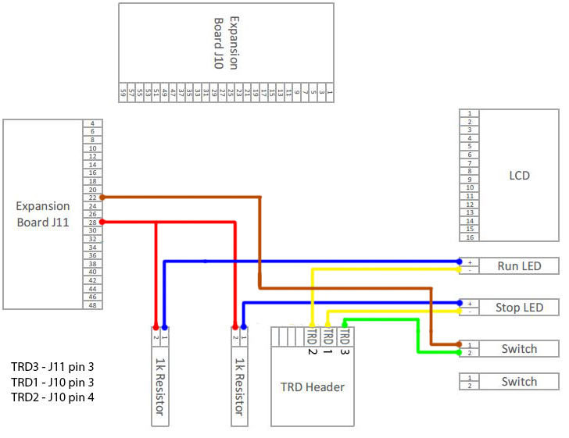

Part 2

Part 3

Tests

Part 1

|  |  |  |
| --- | --- | --- |
| Test Name | Tool | Description |
| Continuity Test | Digital Multi-meter | Test all wire connectors, solder joints, and wire-wraps for continuity |
| Power Test | Digital Multi-meter | Test that any created circuits have power correctly flowing |
| Grounding Test | Digital Multi-meter | Test that any switches connected to ground actually ground a powered circuit |
| Component Test | Digital Multi-meter | Test that appropriate pins on the switch are connected |

Part 2

Part 3

Software

Part 1

|  |  |
| --- | --- |
| Device: | Register(s): |
| **Digital I/O** | TRD0 – PORTGbits.RG13, TRISGbits.RG13  TRD1 – PORTGbits.RG12, TRISGbits.RG12  TRD2 – PORTGbits.RG14, TRISGbits.RG14 |

FSM:

Sw1=1

Wait release 1

Debounce press 1

Wait press 1

Sw1=1

LED run=1 LED stop=0

Debounce release 1

Debounce release 2

LED Stop

Sw1=1

Wait release 2

Debounce press 2

LED run=0 LED stop=1

Sw1=1

Part 2

Part 3